# Apply filters to SQL queries

## Project description

In a fictional scenario, I’m tasked with investigating potential security issues involving login attempts and employee machines. To do this, I’m examining the organization’s data in the employees and log_in_attempts tables, using SQL filters to retrieve records and look into these potential security risks.

## Retrieve after hours failed login attempts

The team is investigating failed login attempts that were made after business hours. My task is to retrieve this information from the login activity. In order to identify all unsuccessful attempts after 18:00 I used the following query

SELECT *

FROM log_in_attempts

WHERE login_time > '18:00' AND success = FALSE

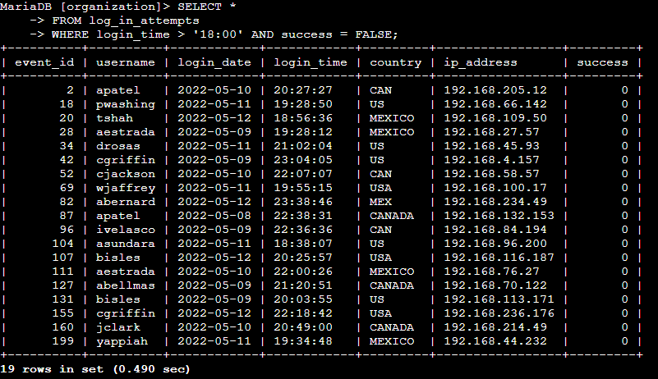

As you can see only the unsuccessful attempts after 18:00 where retrieved.

## Retrieve login attempts on specific dates

The team is investigating a suspicious event that occurred on '2022-05-09'. I want to retrieve all login attempts that occurred on this day and the day before ('2022-05-08'). To accomplish this I used the following:

SELECT *

FROM log_in_attempts

WHERE login_date = '2022-05-09' OR login_date = '2022-05-08';

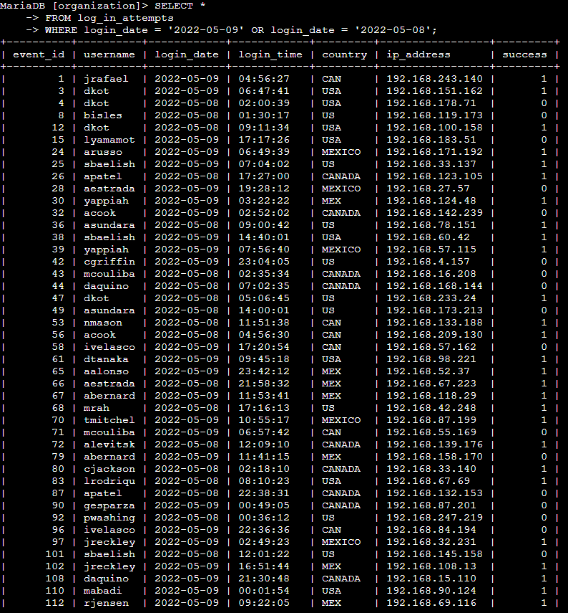

The screenshot above shows that I was able to complete the task successfully.

## Retrieve login attempts outside of Mexico

Now, the team is investigating logins that did not originate in Mexico, and you need to find this information. Note that the country field includes entries with 'MEX' and 'MEXICO'. To retrieve the information I used this query.

SELECT *

FROM log_in_attemtps

WHERE NOT country LIKE ‘MEX%’;

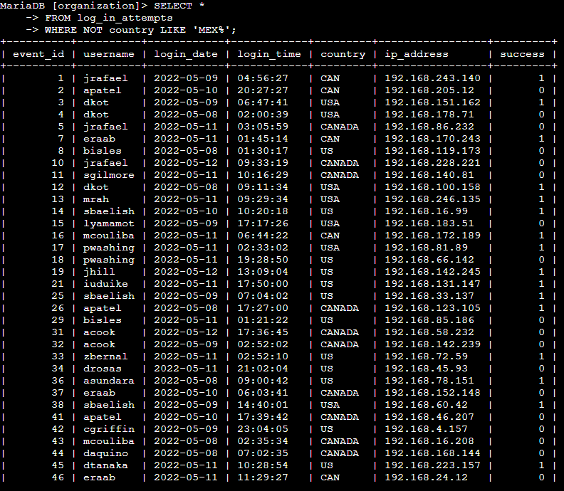

Again the screenshot show that the task was completed successfully;

## Retrieve employees in Marketing

The team is updating employee machines, and you need to obtain the information about employees in the 'Marketing' department who are located in all offices in the East building (such as 'East-170' or 'East-320'). This task can be accomplished with the following query.

SELECT *

FROM employees

WHERE department = ‘Marketing’ AND office LIKE ‘EAST%’;

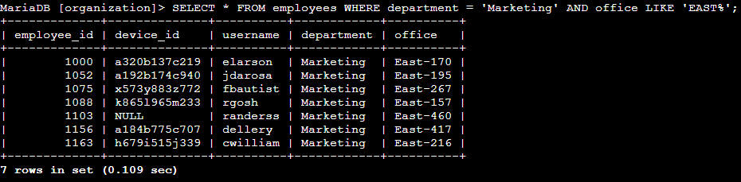

The image above shows that only those employes that are both on the marketing department and on an East office where retrieved

## Retrieve employees in Finance or Sales

Now, the team needs to perform a different update to the computers of all employees in the Finance or the Sales department, and I need to locate information on these employees. I used the following.

SELECT *

FROM employees

WHERE department = ‘Finance’

OR department = ‘Sales’;

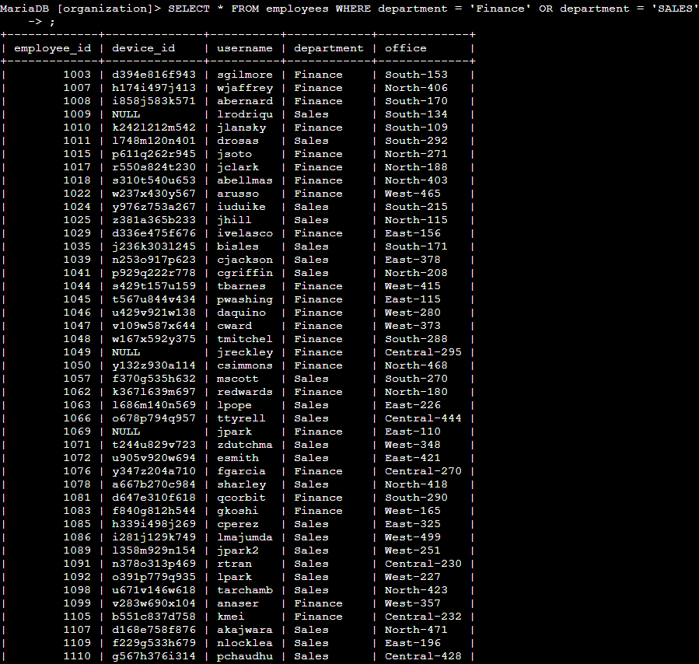

As you can see only those employees that were neither of the departments were returned.

## Retrieve all employees not in IT

Finally the team needs to make one more update. This update was already made to employee computers in the Information Technology department. The team needs information about employees who are not in that department. This can be accomplished very easily using the following.

SELECT *

FROM employees

WHERE NOT department = ‘Information Technology’;

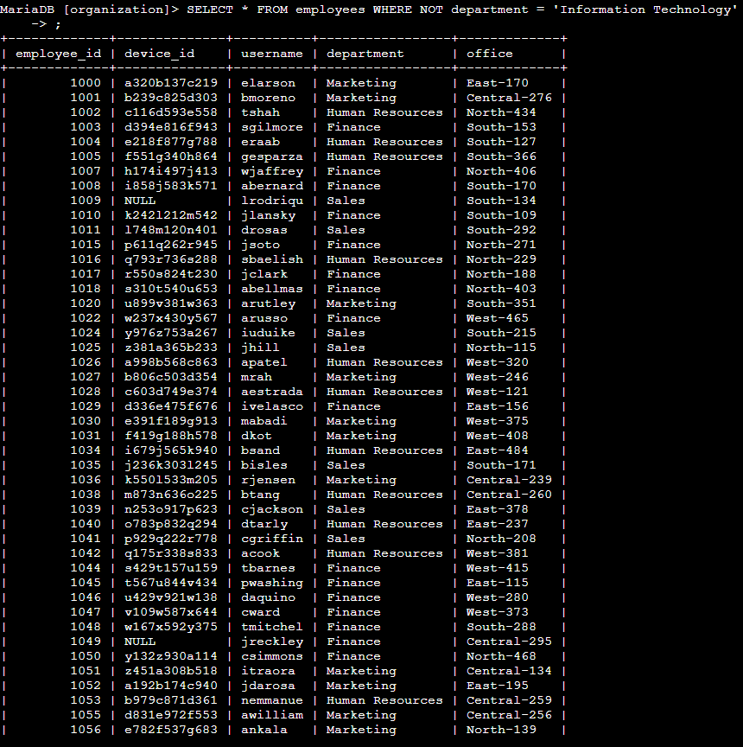

Once again I was able to accomplish the task successfully.

## Summary

Here is a summary of the tasks performed during the investigation.

1. Retrieve Unsuccessful Login Attempts After 18:00: A query was written to retrieve all unsuccessful login attempts after 18:00 using:

SELECT *

FROM log_in_attempts

WHERE login_time > '18:00' AND success = FALSE;

1. Retrieve Login Attempts on Specific Dates: A query was used to retrieve all login attempts on '2022-05-08' and '2022-05-09':

SELECT *

FROM log_in_attempts

WHERE login_date = '2022-05-09' OR login_date = '2022-05-08';

1. Retrieve Login Attempts Outside of Mexico: To find login attempts that did not originate from Mexico, a query was executed that excluded entries with 'MEX' or 'MEXICO':

SELECT *

FROM log_in_attempts

WHERE NOT country LIKE 'MEX%';

1. Retrieve Employees in Marketing at East Building: A query was written to locate employees in the 'Marketing' department who are in any office in the East building:

SELECT *

FROM employees

WHERE department = 'Marketing' AND office LIKE 'EAST%';

1. Retrieve Employees in Finance or Sales: A query was used to retrieve all employees working in either the Finance or Sales departments:

SELECT *

FROM employees

WHERE department = 'Finance' OR department = 'Sales';

1. Retrieve Employees Not in IT: Finally, a query was written to retrieve information on employees not in the Information Technology department:

SELECT *

FROM employees

WHERE NOT department = 'Information Technology';

Each task was completed successfully using efficient SQL queries to meet the team's investigative and operational needs.